Quick Start Guide:

Screen-shot of the application:-

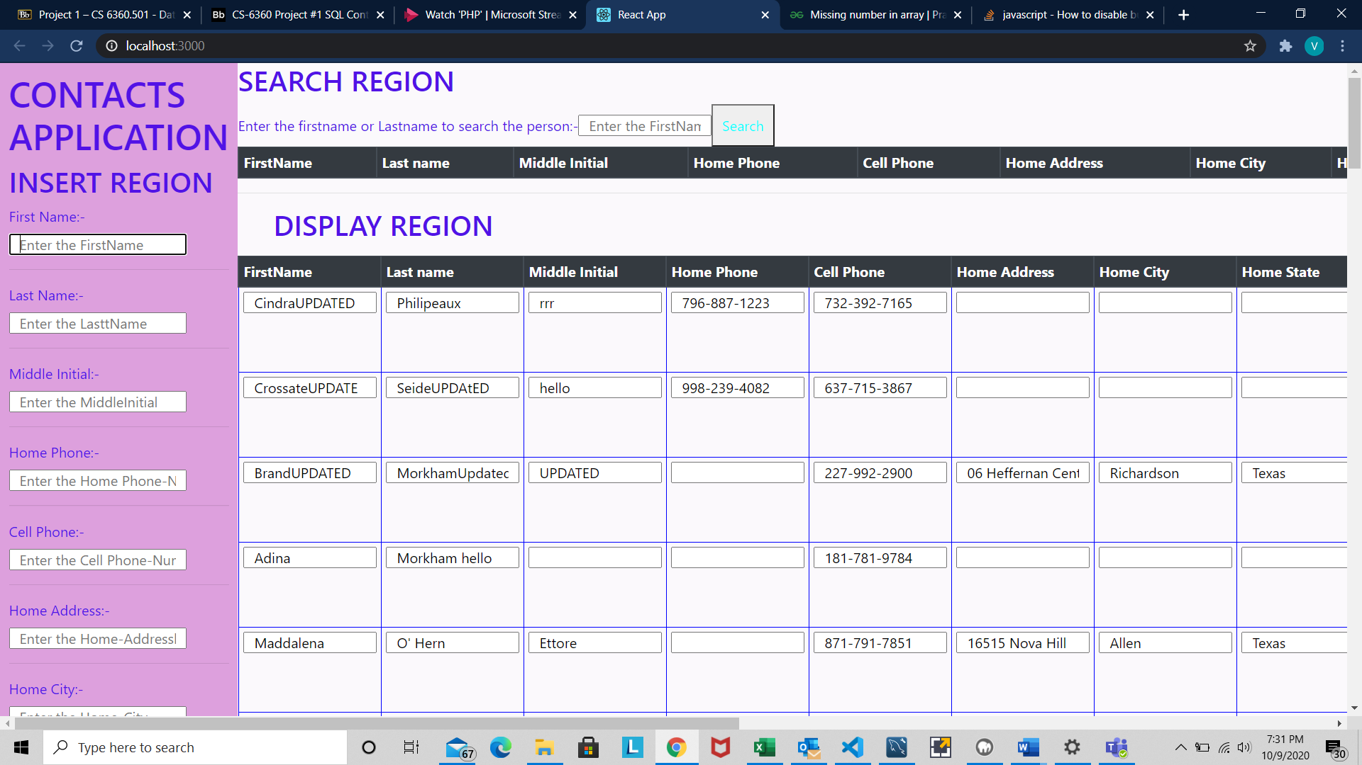

1.Viewing the contacts information:-

As soon as you launch the application you are presented with the complete data that is already stored in the database in a tabular format. This basically serves the display aspect of the application.

2.Searching for a particular entry.

An entry in the database could be searched by typing in any known value about that entry . for eg:- FirstName, LastName, MiddleName,Phone-number etc. All you need to do is type-in the necessary keyword and click on the search button. Now it is important to refresh the application for you to see the recently retrieved data from the backend database.

3.Deleting a particular entry in the database.

Deleting is basically the simplest. Each record/row has a Delete button attached to it.If u want to delete a particular row, just click on the delete button of that particular row. Zrefresh the application to see that the record has been permanently deleted.

4.Updating a particular entry.

Updating is similar to deleting. Just update the required row (each row is editable) .As soon as you have done the changes, click on the Update button of that particular row. Refresh the application to view the changes.

5.Inserting the new row into the database.

As soon as you launch the application you can see a form on the left hand side which basically receives the user input. You can type in all the details as necessary and click on the Insert button. Your data is now added to the database and you can view it after you refresh the display .